Step1: Dowload Google Colab

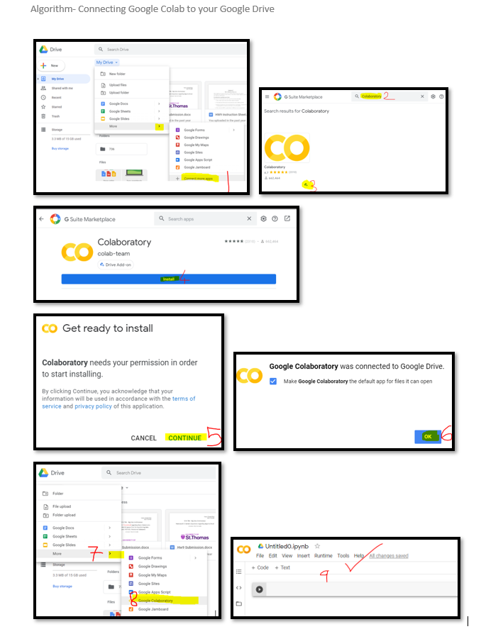

Step2: Navigate to the google colab notebooks

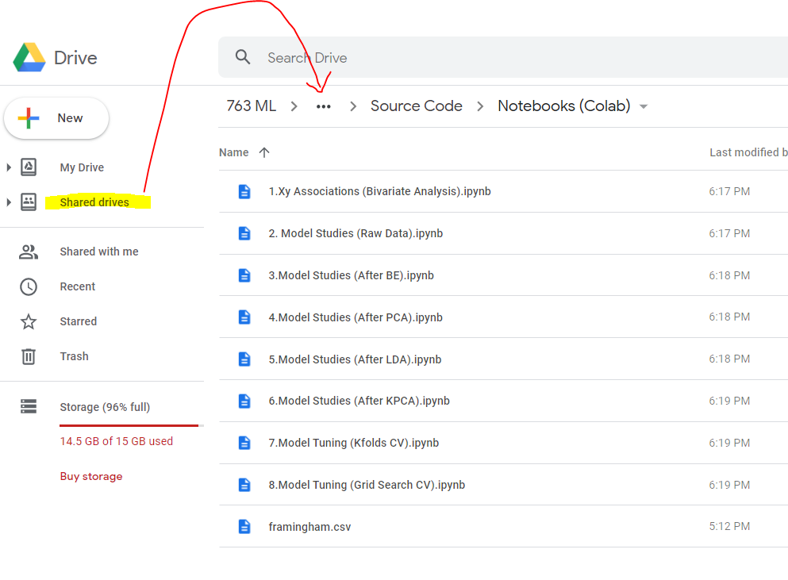

Step3: Click on any of the google colab notebooks and select **Open with Google Collaboratory**

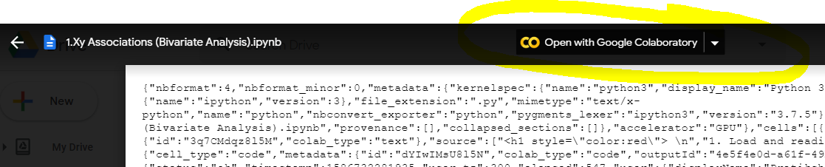

Step4: Verify that you can successfully open the google colab notebook

